Front-End (React) Coding Challenge

(Duration 3 hours)

Create a React Application that manages a tasks information. Implement the following requirements in React Application:

1. Provide the following navigations from the home page:

a. Home

b. Tasks

c. About Us

d. Contact Us

e. Login

2. Home Page: It should provide navigation links, Banner, Footer, Some Information about the website.

3. Tasks Page:

a. Each task should have the following attributes:

· Task ID, Title, Description, Due Date, Priority (Low, Medium, High), Status (Pending, In Progress, Completed)

b. Allows Display all tasks details, Add a task, (Delete – Optional)

c. Try to display tasks details in cards format

d. Data should exchange between Express API and React App

e. It is protected page, user can access this page only after login with proper credentials.

4. Login Page:

a. Verify the credentials in client application and use some static value as token

b. No need to communicate with server

5. About and Contact Page:

a. Provide the required information in these pages and add some images suitable to this requirement.

Points to be considered while implement the above Requirements:

· Use Express JS for back-end REST API.

· Should implement service in Front-end Application to communicate with server

· Optionally: Apply styles where ever it is required

· Should follow the proper coding standards in components, service development

· Should implement not found route also

Task-App Images

Home Page

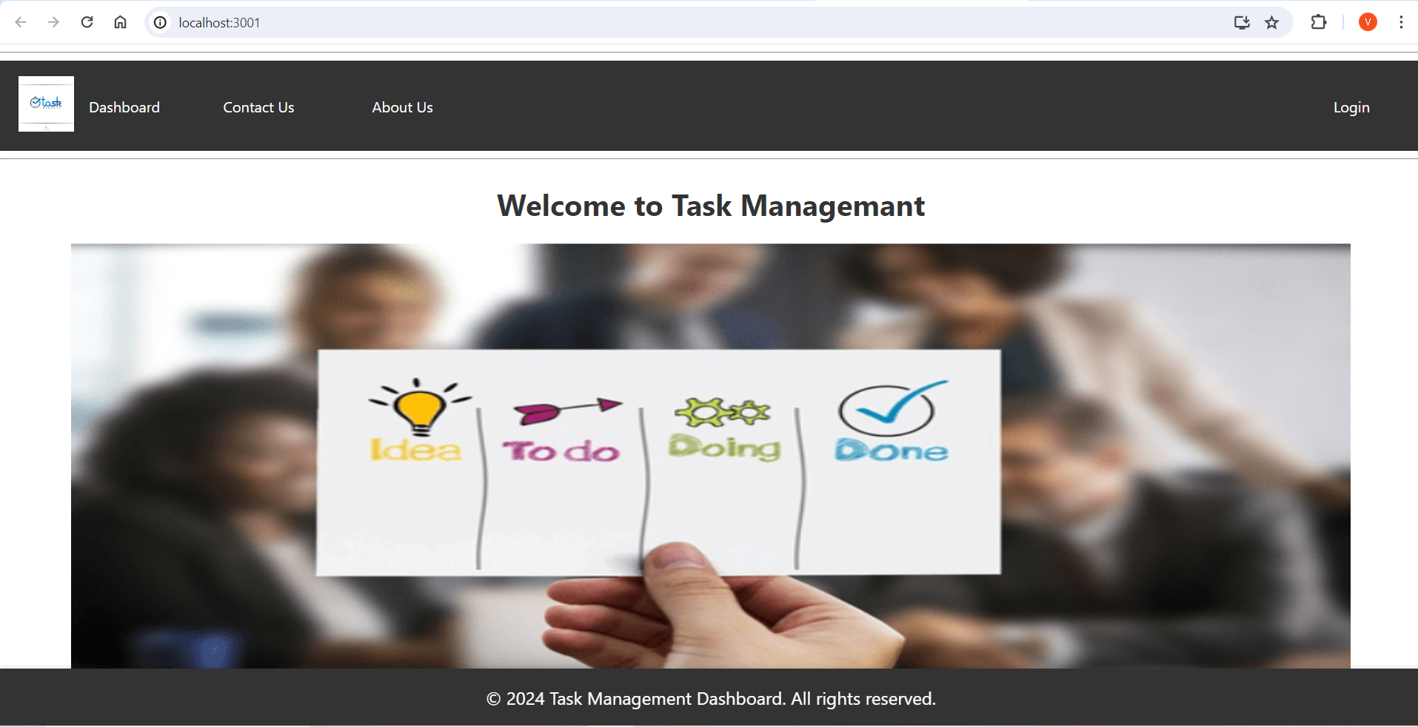

Login Page

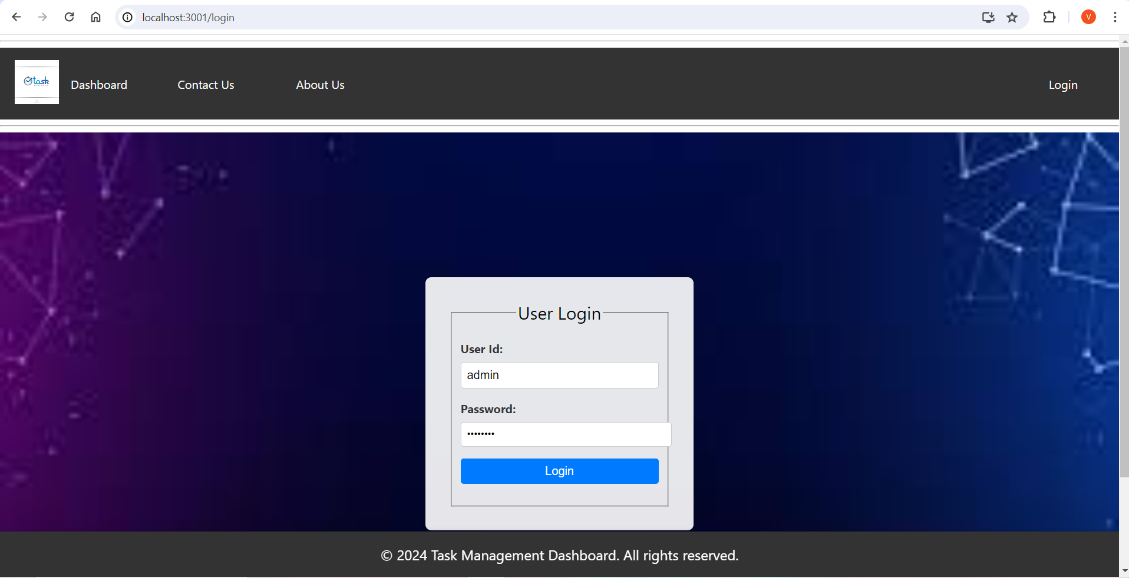

Dashboard Page

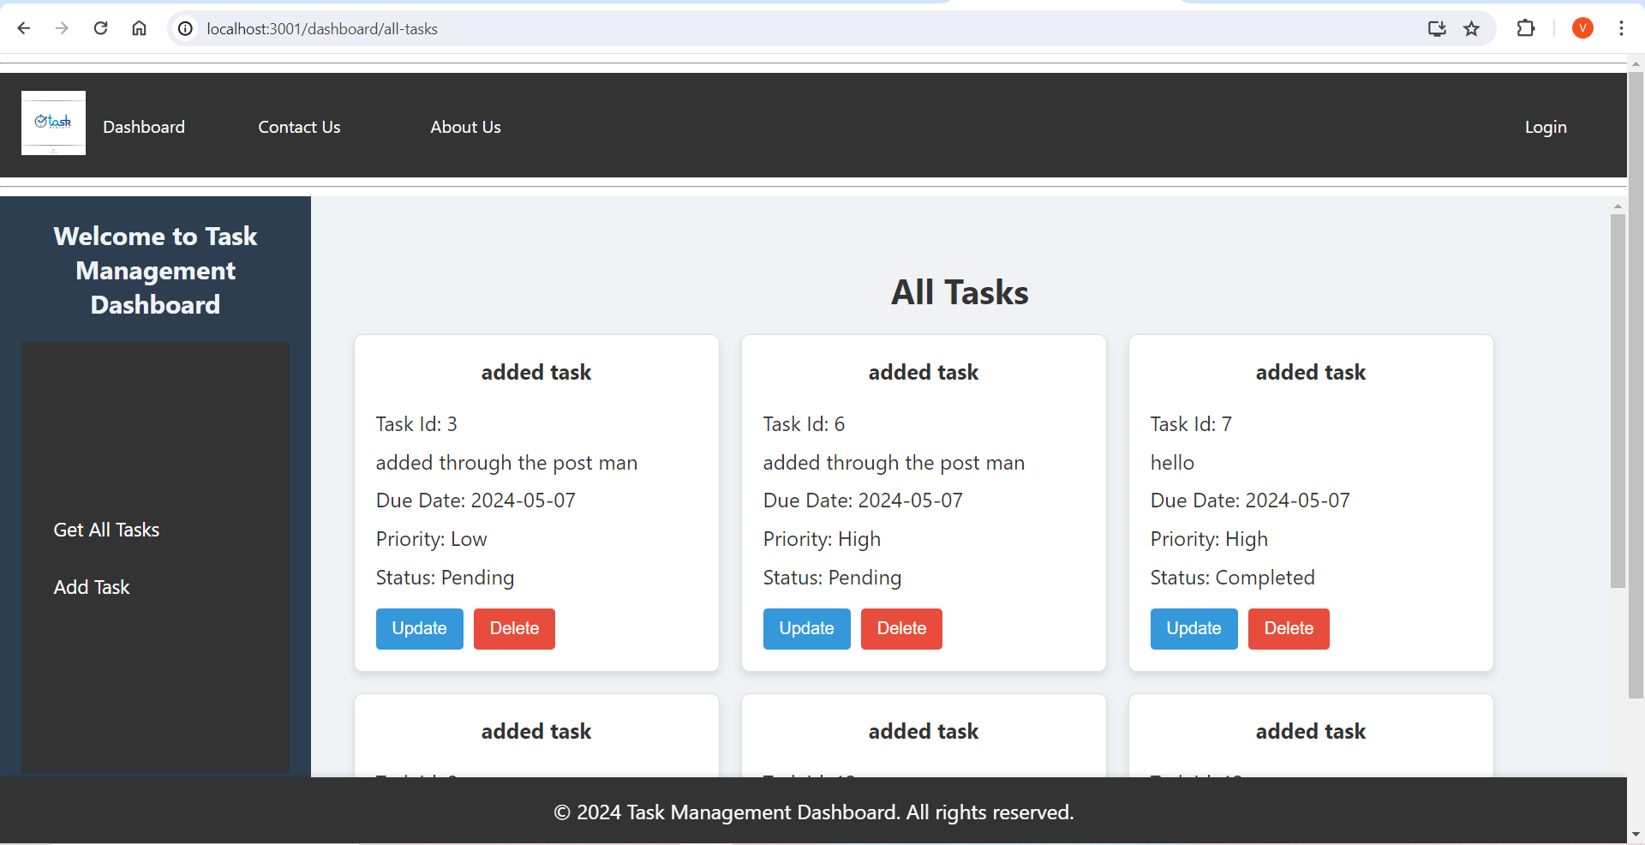

Delete Task Page

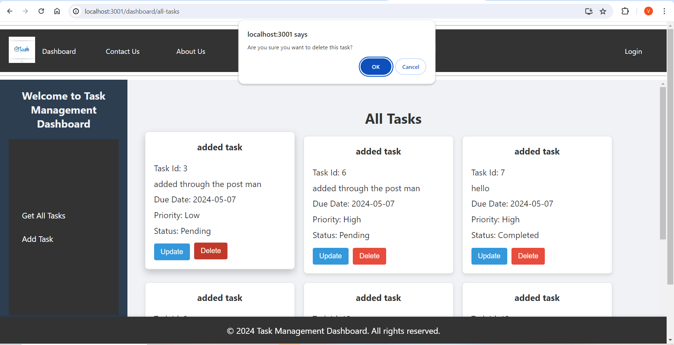

Update Task Page

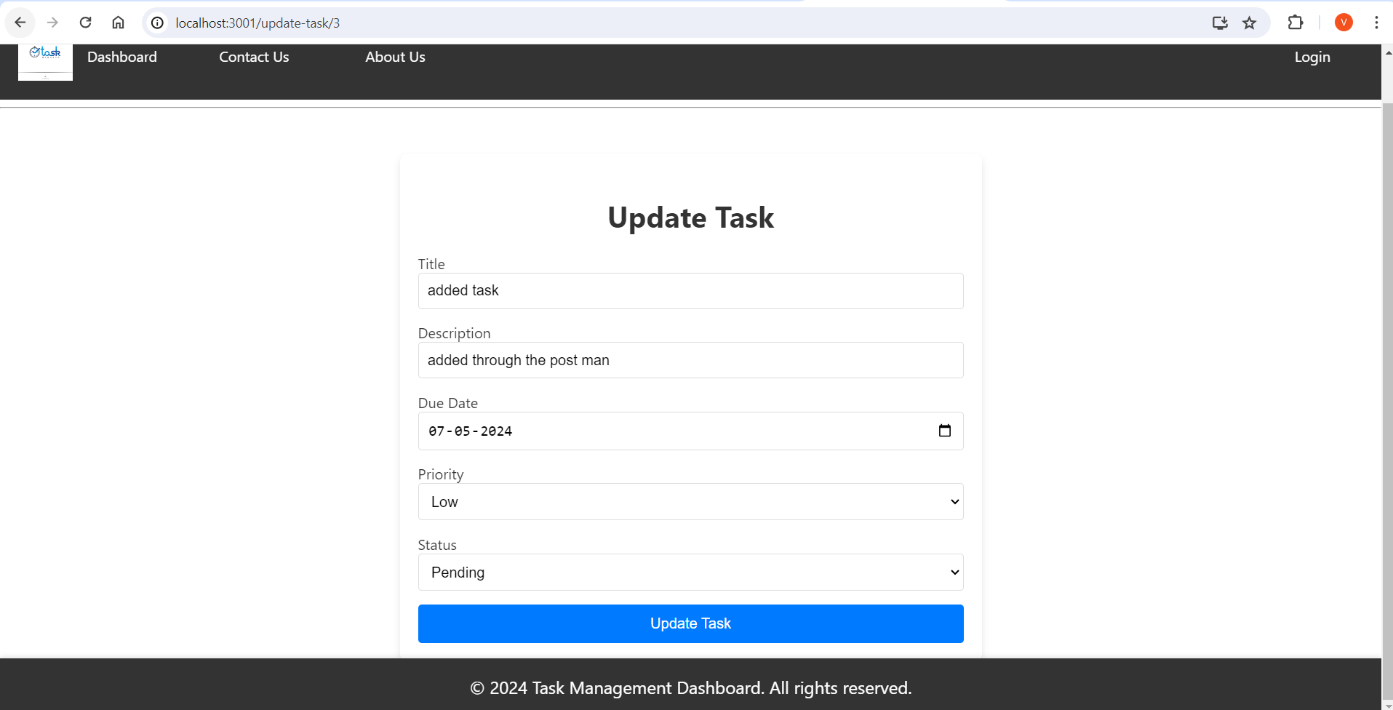

Add Task Page

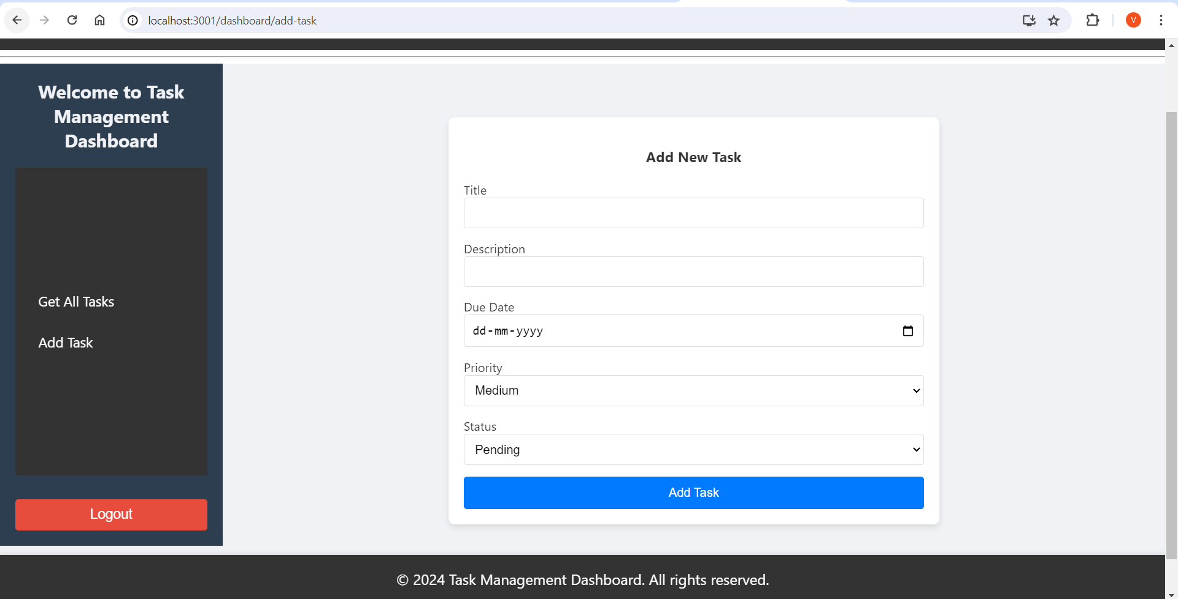

Contact us Page

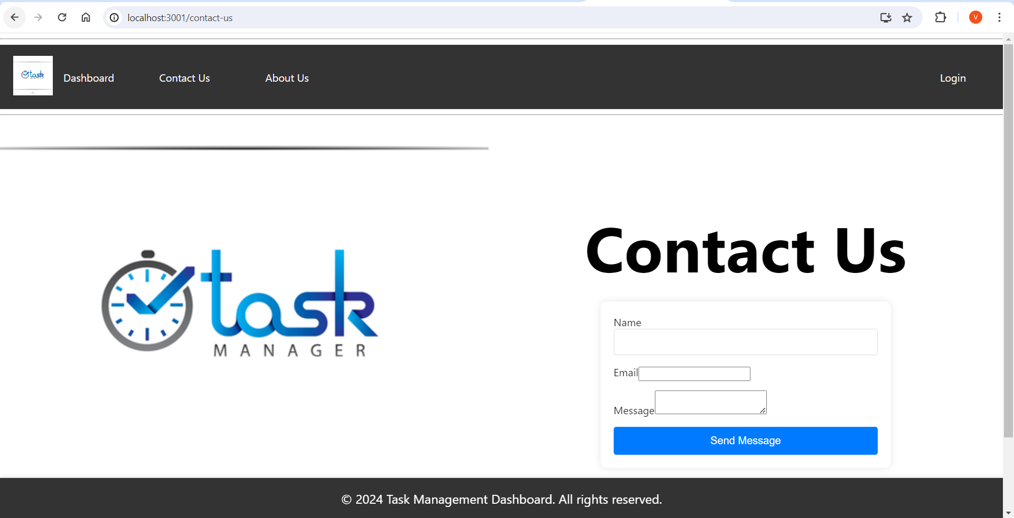

About us Page

